GUVI ASSIGNMENT

Create a database worker that should contain **first name, last name email, department, salary, Join Date** with 50 employees.

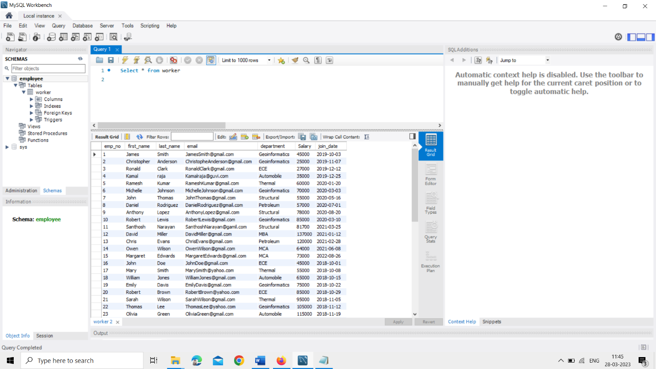

1.Write an SQL query to fetch “FIRST_NAME” from the Worker table using the alias name as <WORKER_NAME>

ANS : Select first_name as worker_name from worker;

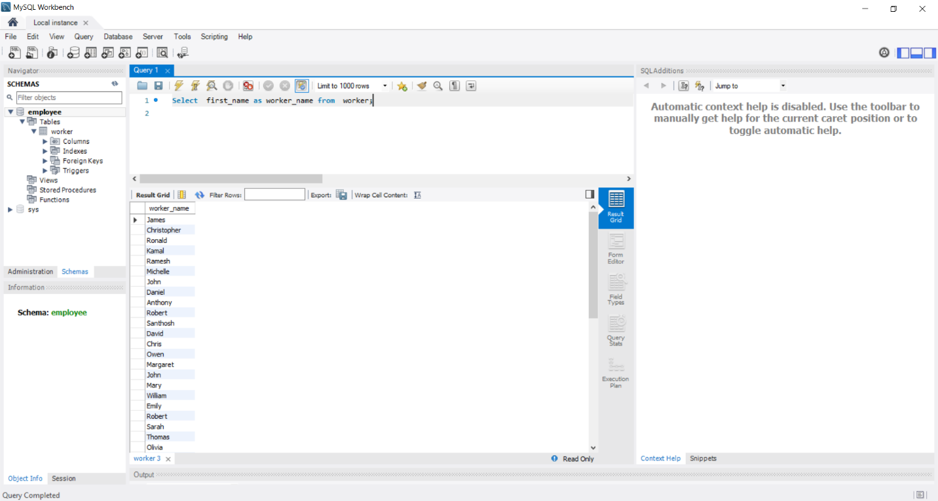

2.Write an SQL query to fetch unique values of DEPARTMENT from the Worker table.

ANS : Select DISTINCT department from worker;

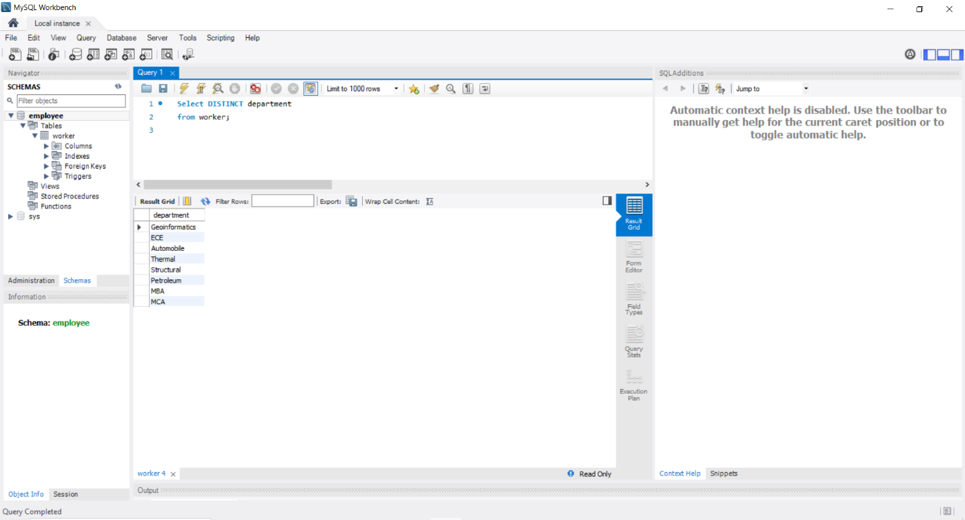

3. Write an SQL query to show the last 5 records from a table.

ANS : (Select * from worker order by emp_no DESC limit 5) order by emp_no ASC;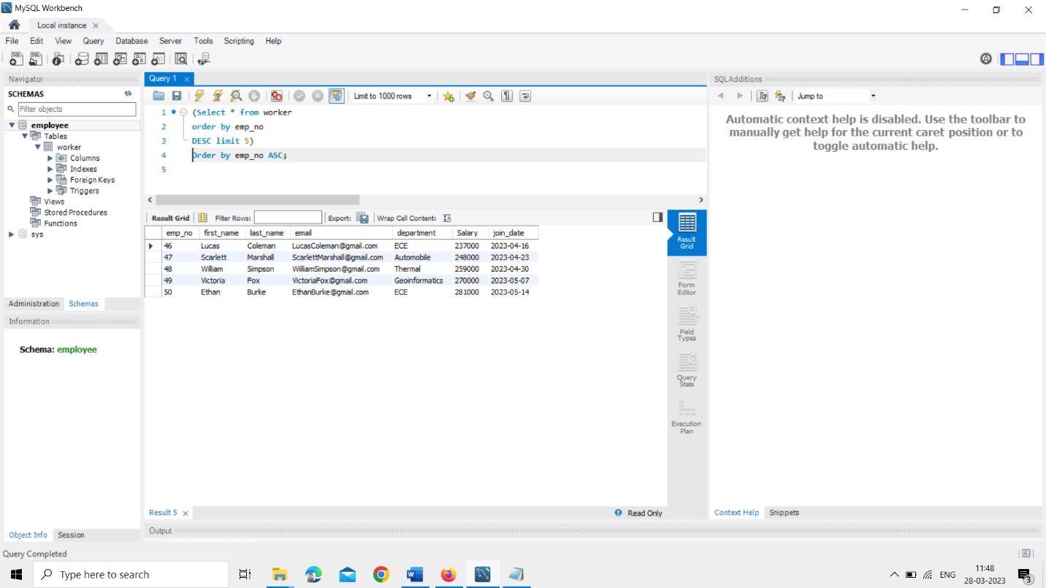

**TASK-2**

1. Write an SQL query to print the first three characters of FIRST_NAME from Worker.

ANS : Select substring(first_name,1,3) from worker;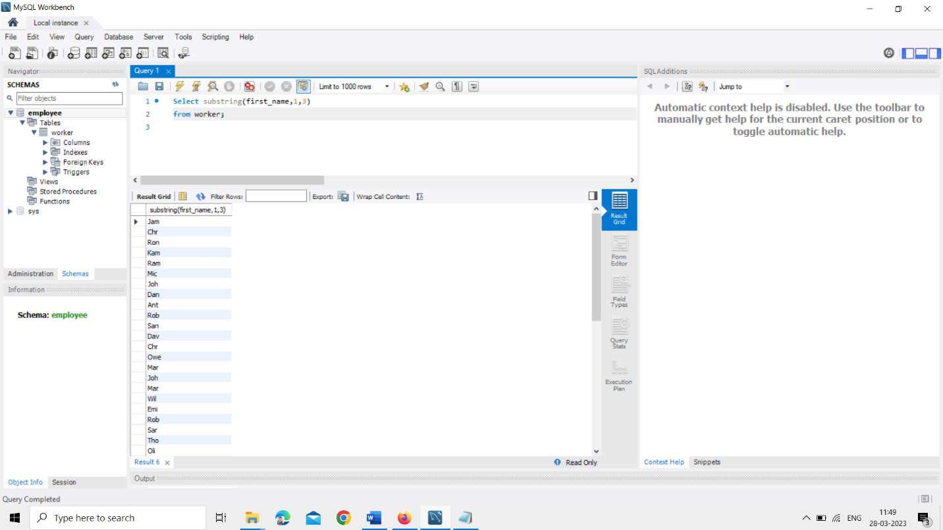

2. Write an SQL query to find the position of the alphabet (‘a’) in the first name.

ANS : Select first_name, position('a' IN first_name) from workers

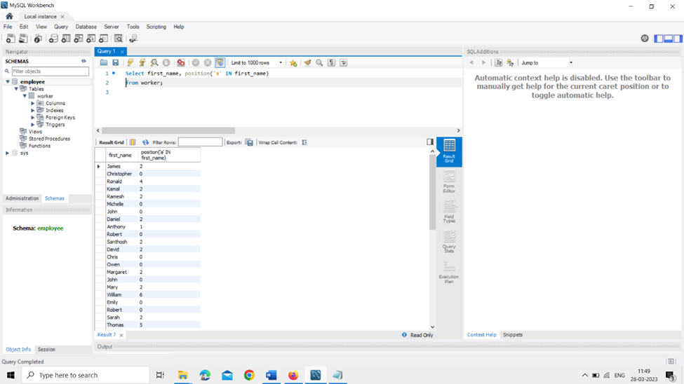

3. Write an SQL query to print the name of employees who have the highest salary in each department.

ANS : SELECT emp_no, department, MAX(salary) FROM worker GROUP BY department

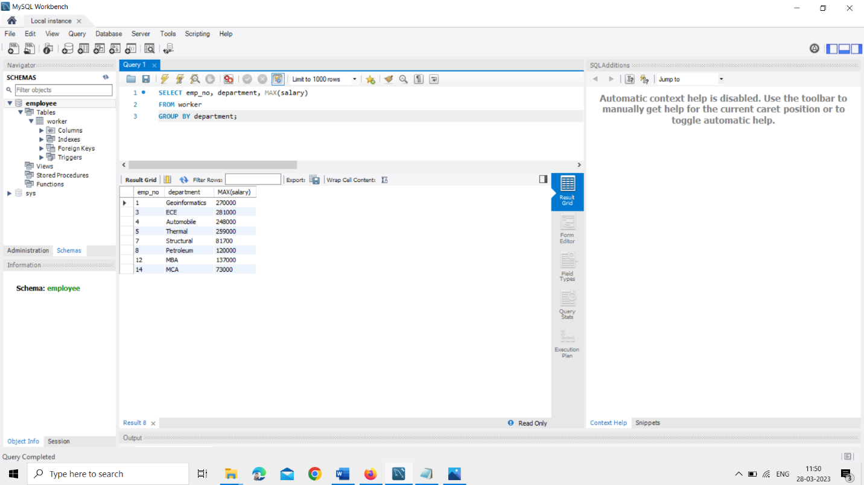

**TASK-3**

1.Write an SQL query to print the FIRST_NAME from the Worker table after removing white spaces from the right side.

ANS : Select RTRIM(first_name) from worker

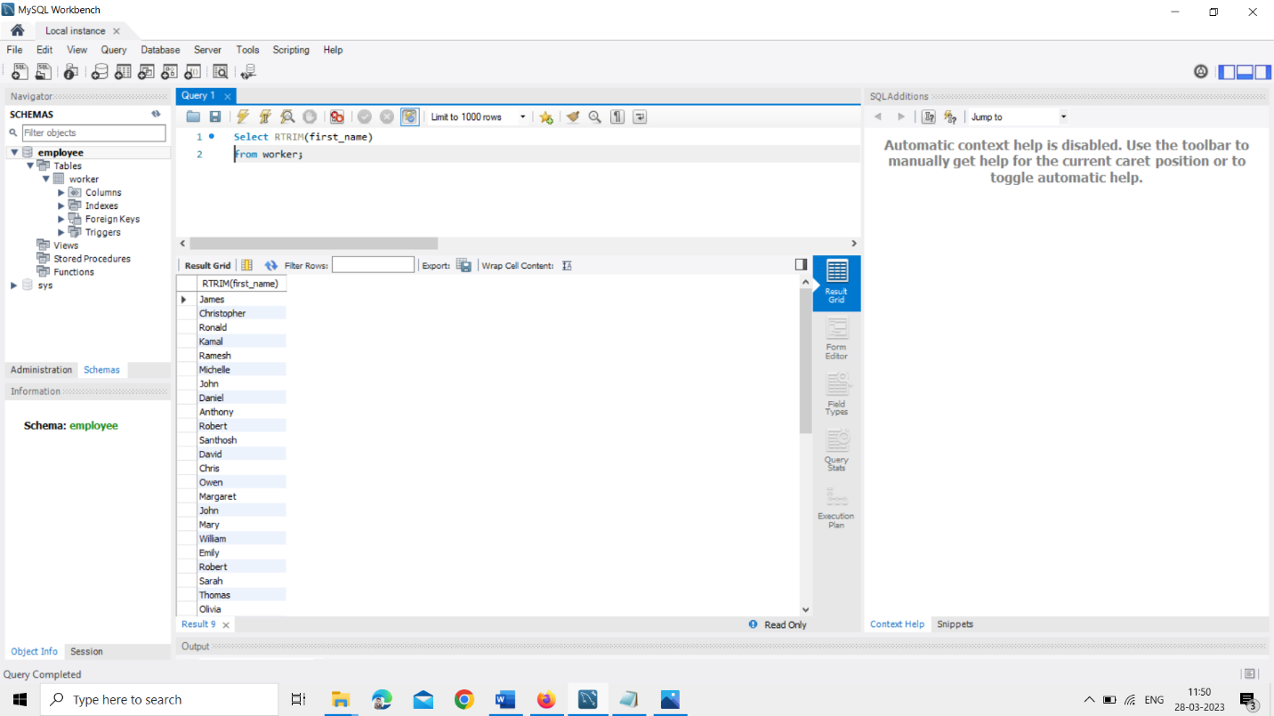

2.Write an SQL query that fetches the unique values of DEPARTMENT from the Worker table and prints its length

ANS : Select DISTINCT department, LENGTH(department) from worker

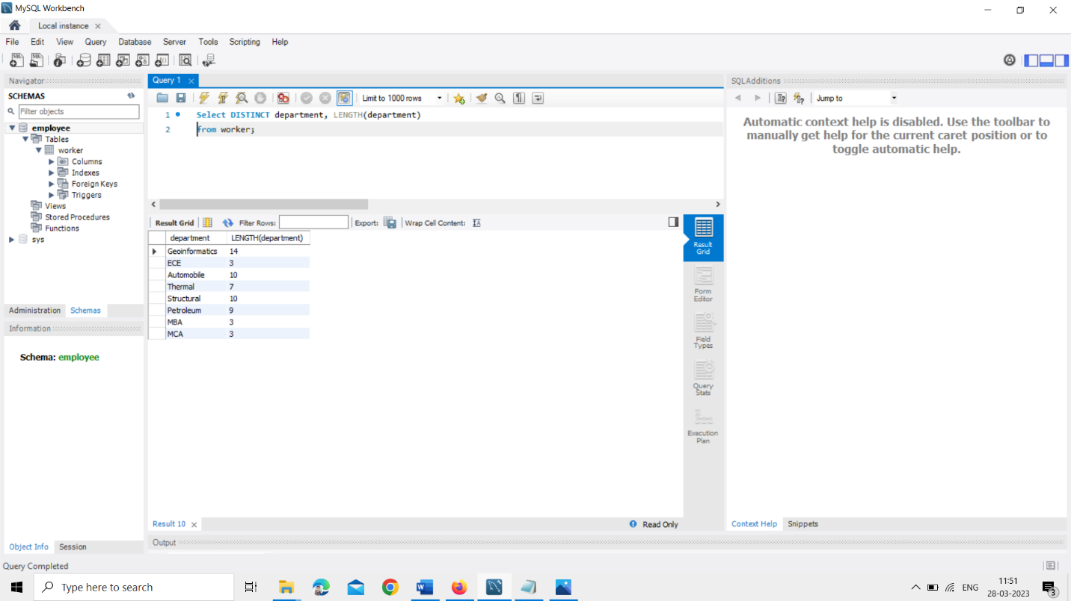

**3.** Write an SQL query to fetch nth max salaries from a table.

ANS : SELECT Salary FROM employee ORDER BY Salary DESC LIMIT 5-1,1;

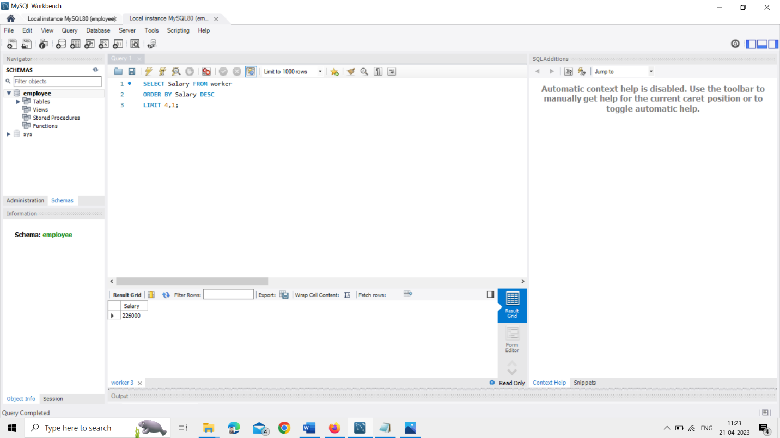

**TASK-4**

1.Write an SQL query to print the FIRST_NAME from the Worker table after replacing ‘a’ with ‘A’.

ANS : Select REPLACE(first_name,'a','A') from worker;

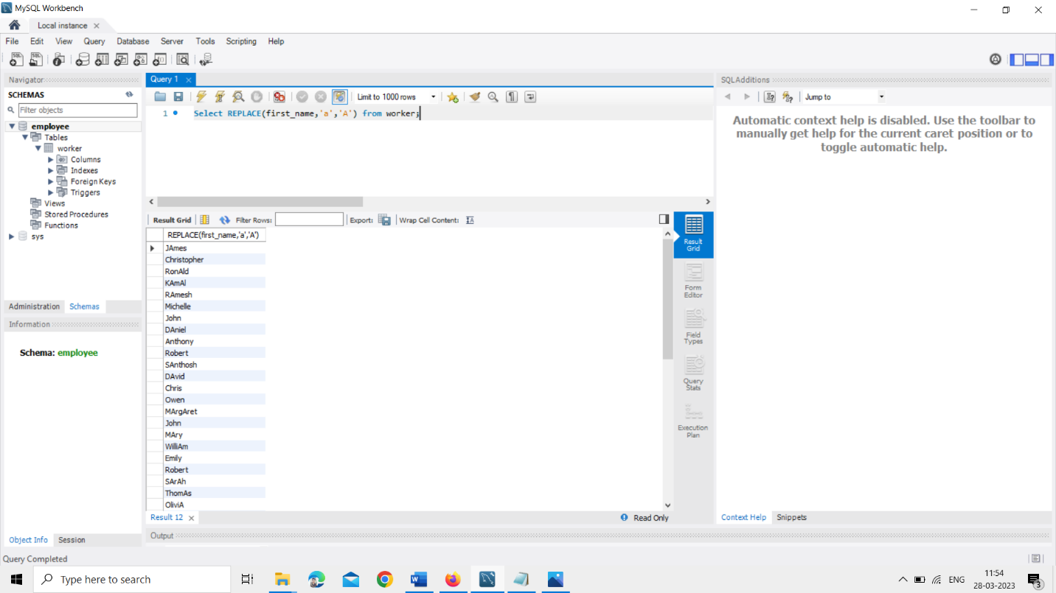

2. Write an SQL query to print all Worker details from the Worker table order FIRST_NAME Ascending and DEPARTMENT Descending.

ANS : Select * from worker order by first_name asc, department desc

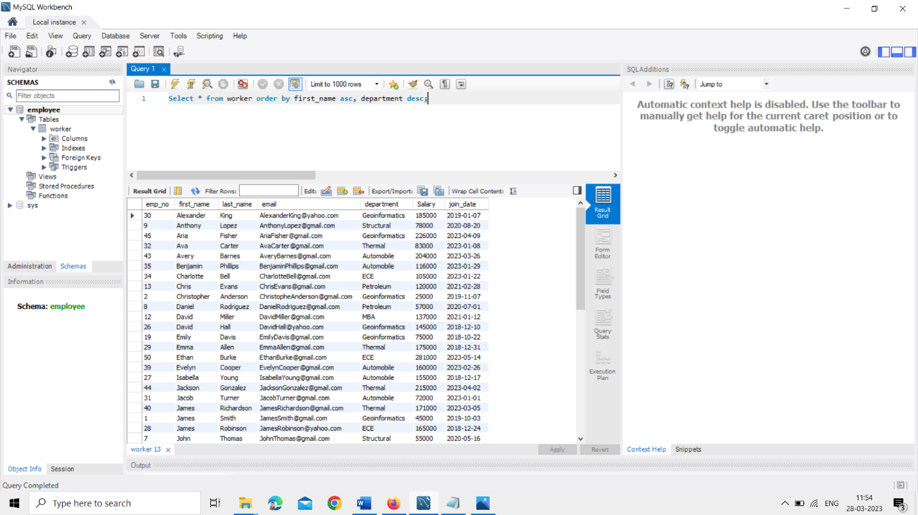

3. Write an SQL query to fetch the names of workers who earn the highest salary

ANS : Select first_name, max(Salary) from worker

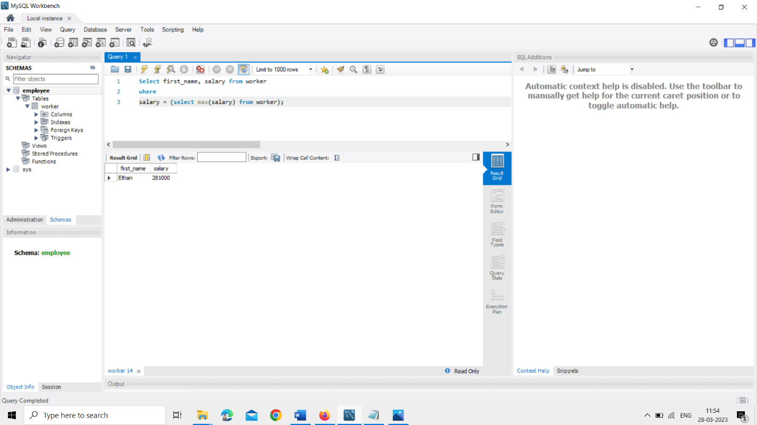

**TASK-5**

1.Write an SQL query to print details of workers excluding first names, “Ramesh” and “Santhosh” from the Worker table.

ANS : Select * from worker where first_name NOT IN ('Ramesh', 'Santhosh')

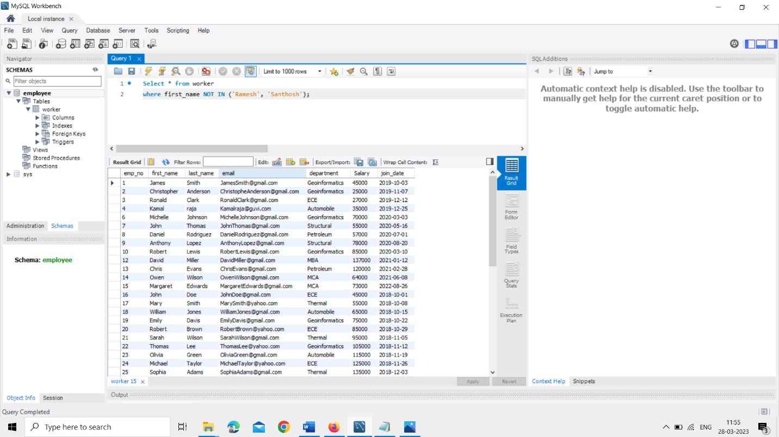

2. Write an SQL query to print details of the Workers whose FIRST_NAME ends with ‘h’ and contains six alphabets.

ANS : SELECT * FROM worker WHERE first_name LIKE '_____h'

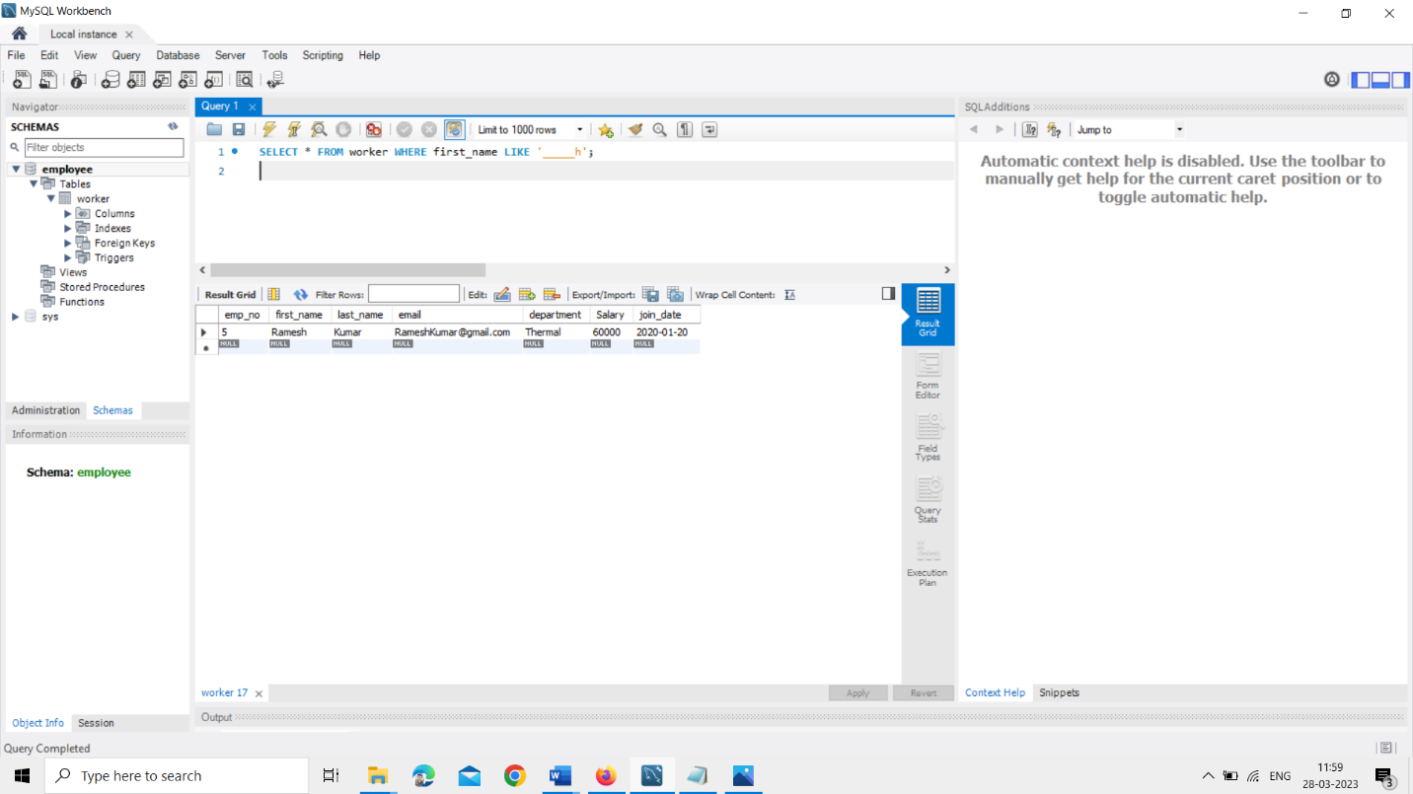

3. Write a query to validate Email of Employee (email should have first name last name and guvi.com example (first name=Kamal last name= raja and the mail id should be [kamalraja@guvi.com](mailto:kamalraja@guvi.com)).

ANS : Select first_name, email from worker where email like '%guvi.com';

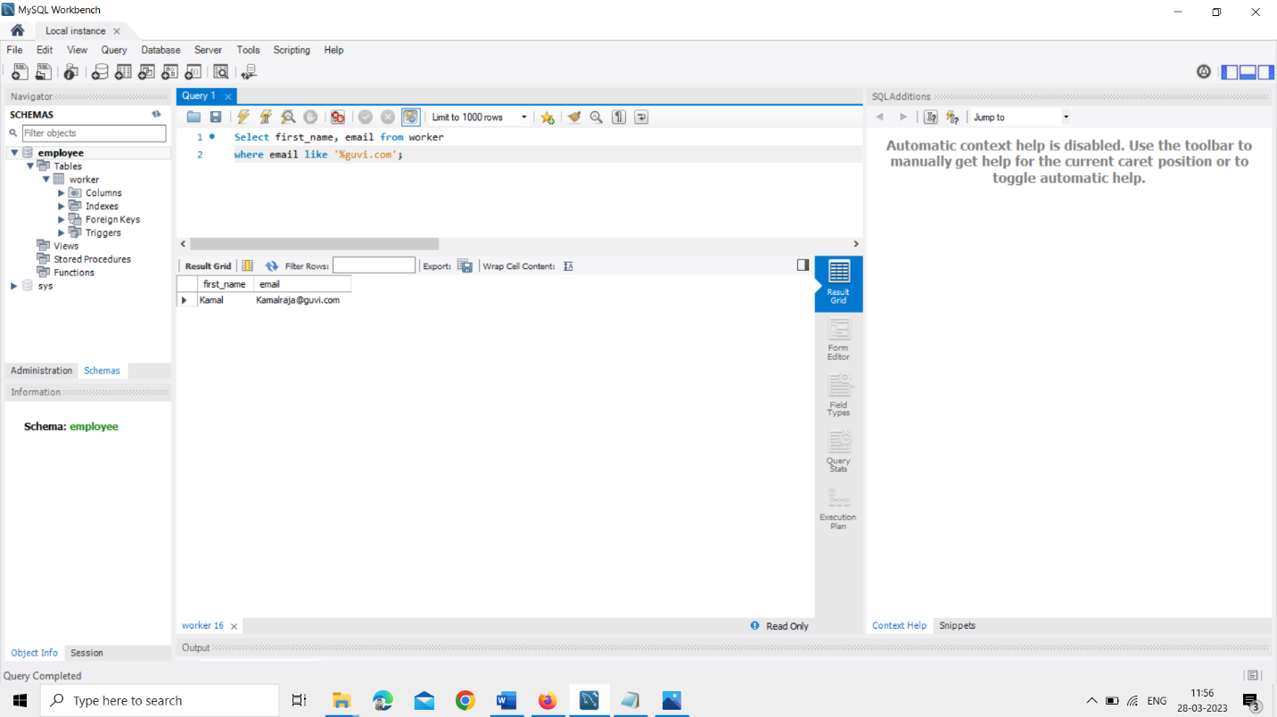

**TASK-6**

**1.** Write an SQL query to print details of the Workers who have joined in March ’2021.

ANS : Select * from worker where year(join_date) = 2021 and month(join_date) = 3;

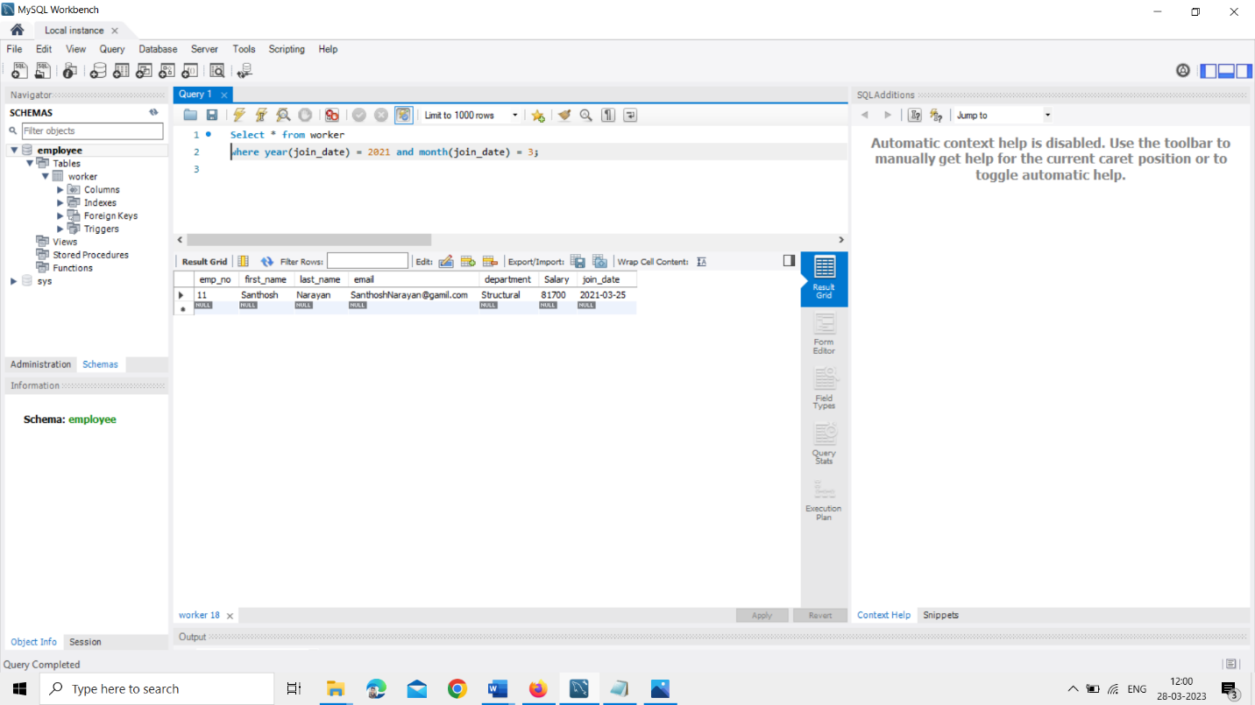

2.Write an SQL query to fetch duplicates that have matching data in some fields of a table.

ANS : Select department, first_name, COUNT(*) FROM worker GROUP BY department, first_name HAVING count(*) > 1

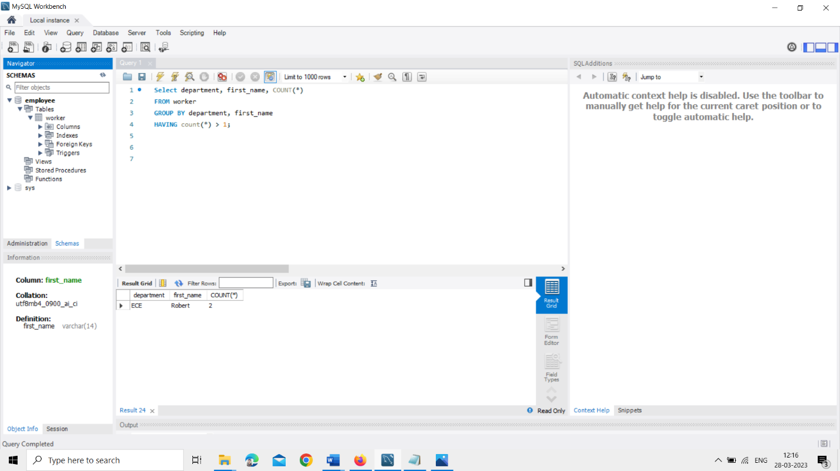

3.How to remove duplicate rows from the Employees table.

ANS : Here you can see the query is executed below in action output.

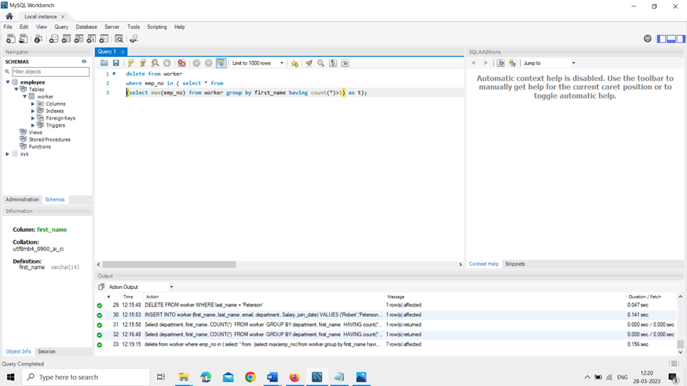

**TASK-7**

1.Write an SQL query to show only odd rows from a table.

ANS : Select * from worker where mod(emp_no,2)<>0;

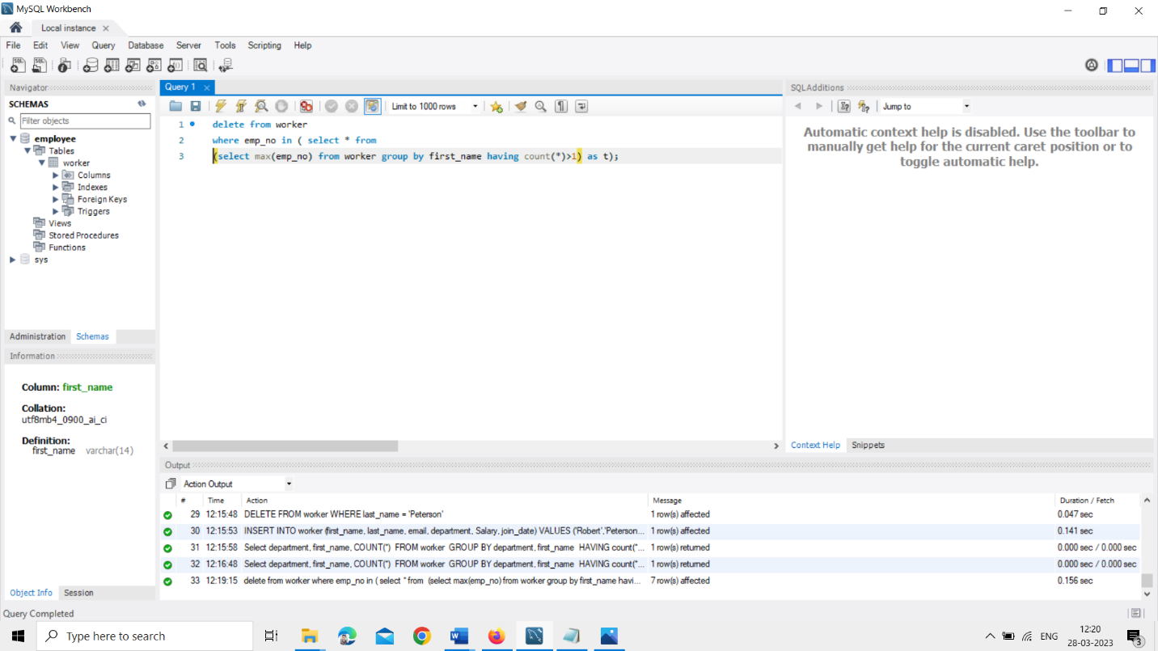

**2.** Write an SQL query to clone a new table from another table.

ANS : Create table worker_2 like worker; insert into worker_2 select * from worker;

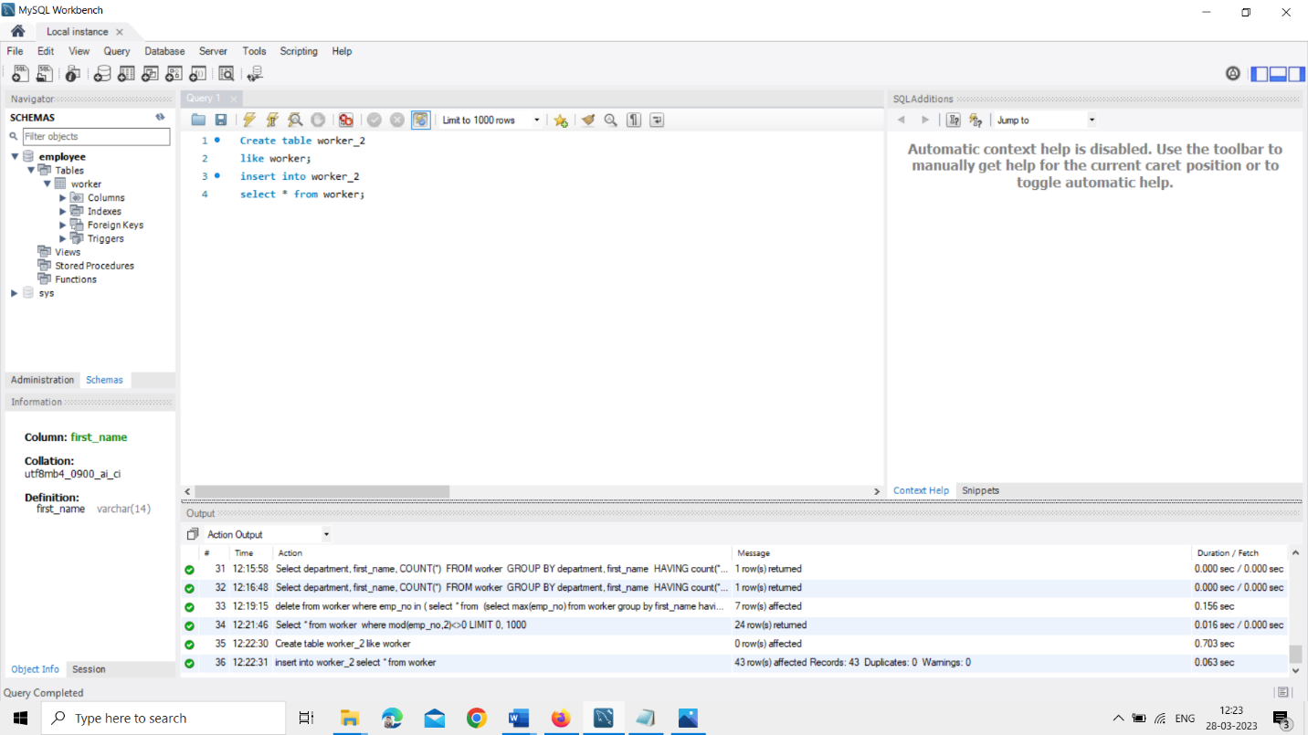

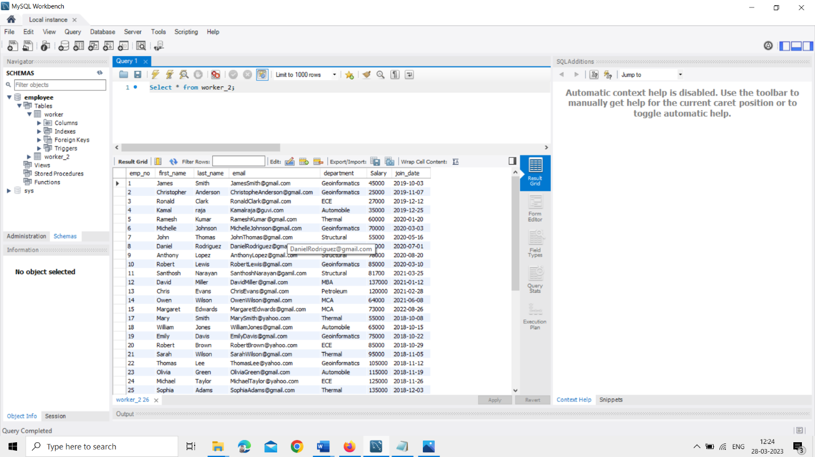

**TASK-8**

1.Write an SQL query to fetch intersecting records of two tables.

ANS : Select emp_no, first_name,last_name from worker left join city on worker.emp_no = city.id

INTERSECT

Select emp_no, first_name,last_name from worker right join city on worker.emp_no = city.id

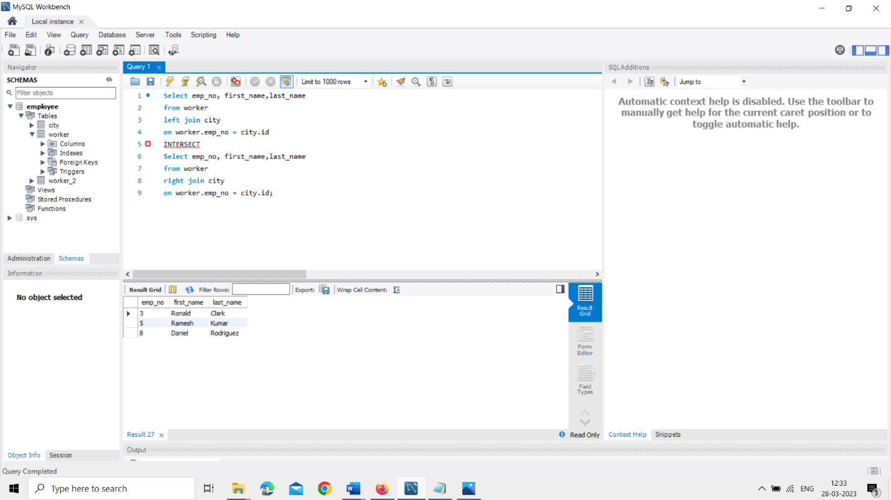

2.Write an SQL query to show records from one table that another table does not have.

ANS : SELECT * FROM worker2 WHERE first_name NOT IN (SELECT first_name FROM worker);

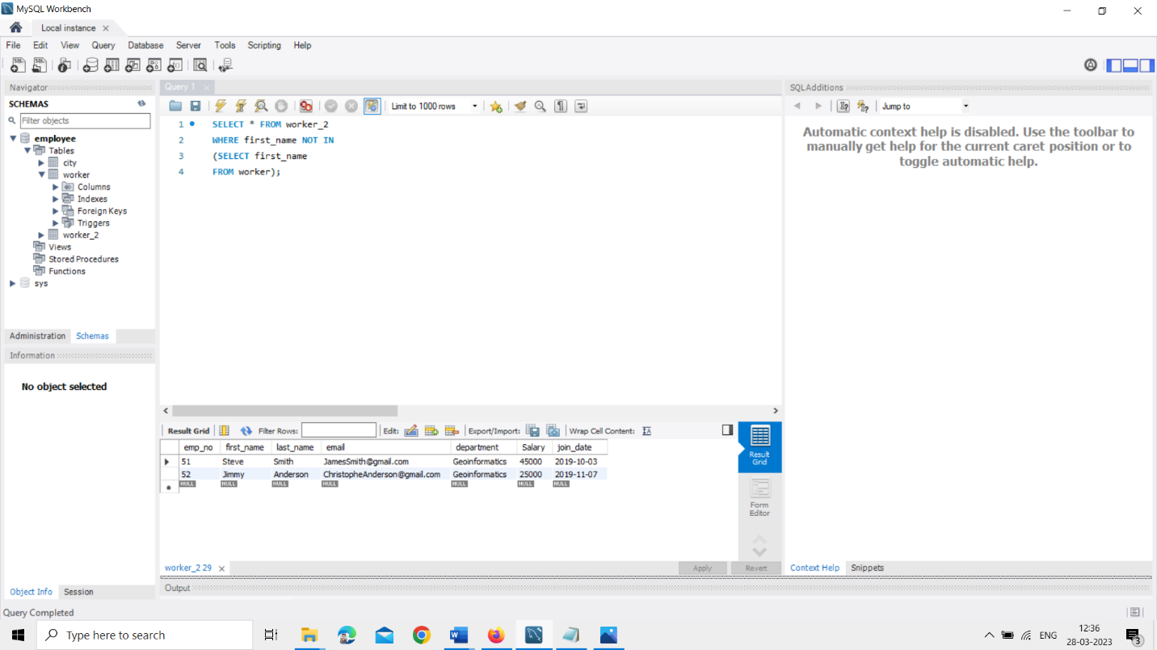

**TASK-9**

1.Write an SQL query to show the top n (say 15) records of a table.

ANS : SELECT first_name,last_name, Salary FROM Worker ORDER BY Salary DESC LIMIT 14;

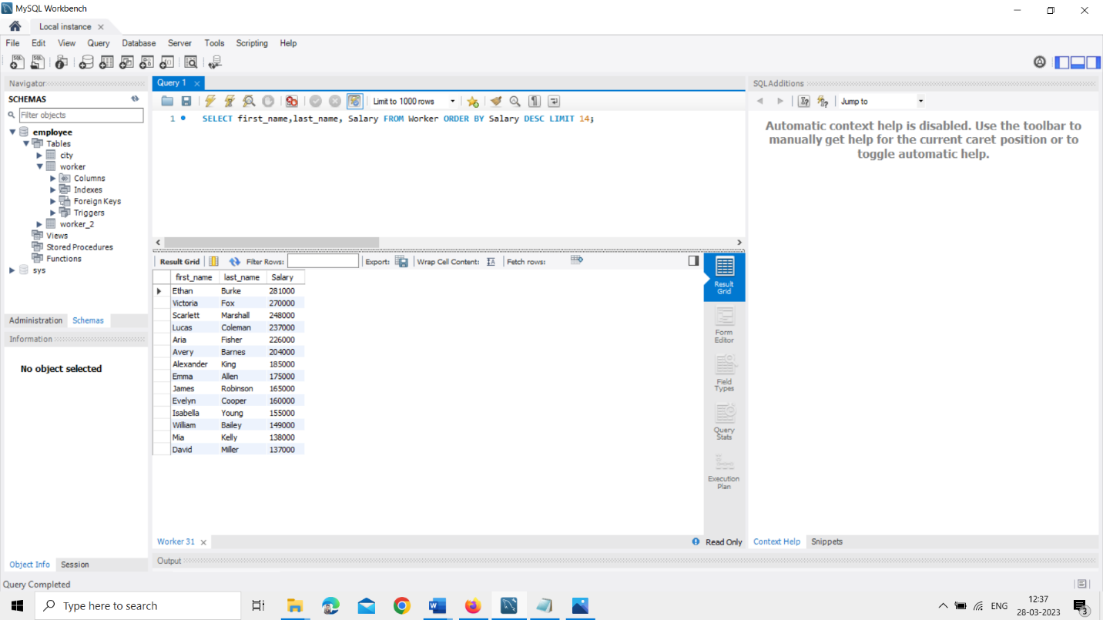

**2.** Write an SQL query to determine the nth (say n=10) highest salary from a table.

ANS : SELECT first_name,last_name, Salary FROM Worker ORDER BY Salary DESC LIMIT 5,1;

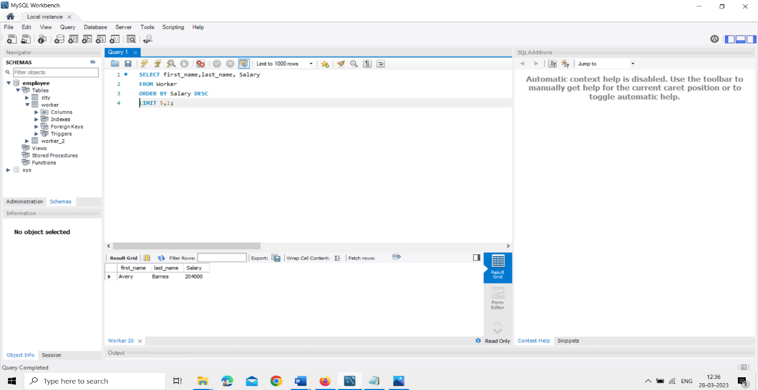

**TASK-10**

1.Write an SQL query to determine the 8th highest salary without using TOP or LIMIT methods.

ANS : SELECT first_name, Salary FROM (SELECT first_name, Salary, RANK() OVER (ORDER BY Salary DESC) as salary_rank FROM worker) ranked_salaries WHERE salary_rank = 1

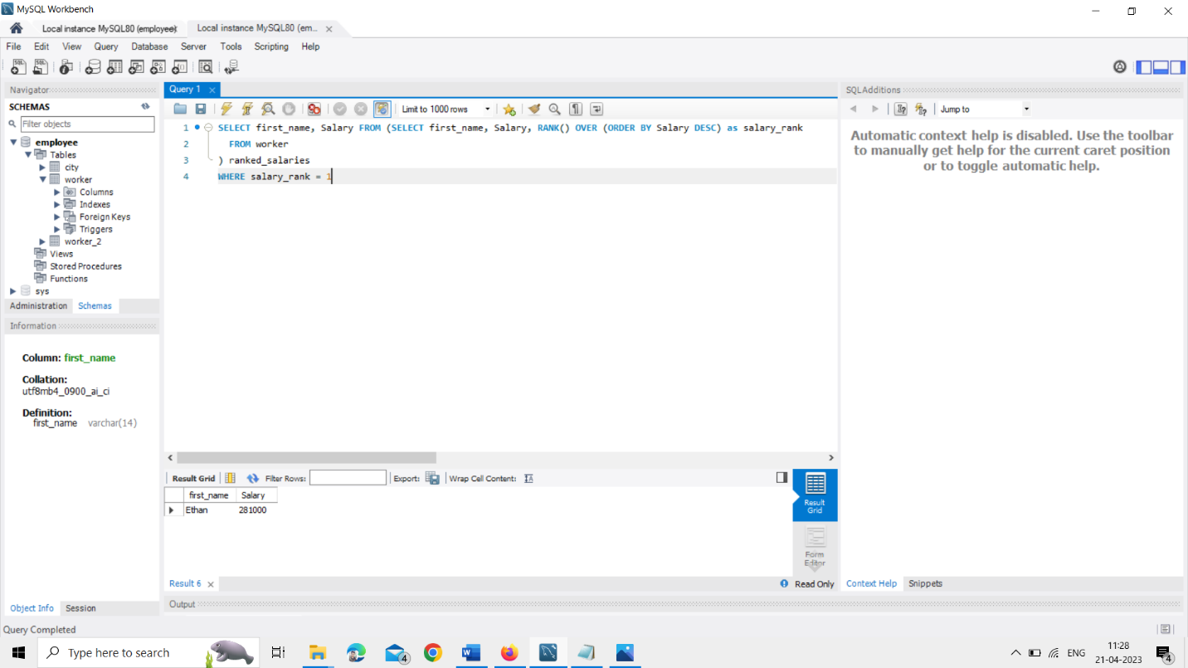

2.Write an SQL query to fetch the list of employees with the same salary.

ANS : Select distinct W.emp_no, W.FIRST_NAME, W.Salary from Worker W, Worker W1 where W.Salary = W1.Salary and W.emp_no != W1.emp_no;

